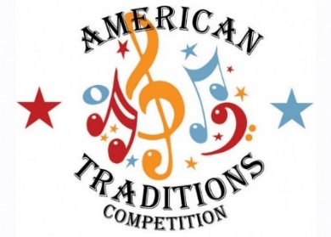
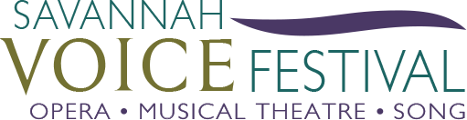

SHERRILL MILNES TO PRESENT AMERICAN OPERA AWARD DURING 2017 AMERICAN TRADITIONS VOCAL COMPETITION

SAVANNAH, GA – February 1, 2017 - The American Traditions Vocal Competition (ATC) is excited to confirm that opera legend, Sherrill Milnes, will present the competition’s new award for the best aria - the Sherrill Milnes American Opera Award on stage and in person at the finals of the 24th ATC during the evening of Friday Feb. 24th at the historic Savannah Theatre on Bull Street.

This award, given by Sherrill Milnes and Maria Zouves, founders of the Savannah VOICE Festival (SVF), will be presented for the best performance of an American opera aria by one of the 28 ATC finalists during either the quarter or semi-finals along with a prize of $500. This collaboration between the SVF and ATC is a further cementing of the relationship between the two musical non-profit organizations which celebrate and honor the human voice. Milnes first came to Savannah as a judge for the American Traditions Vocal Competition and in 2013 launched The Savannah VOICE Festival which will return to Savannah this August for its fifth season of presenting operas, concerts, other events, and educational programs. Many SVF alumnae have competed in the ATC in recent years including Jessica Ann Best in 2015 and who will also return this February; Ashley Dannewitz in 2016 and Mikki Sodergren – Gold Medal winner in 2014.

“I am delighted to have the opportunity to present this award to a deserving contestant and thankful for this collaboration with the American Traditions Vocal Competition” Milnes said. “This relationship between the Savannah VOICE Festival and the ATC is bound to bring even more attention to Savannah as a growing center of vocal excellence.”

Sherrill Milnes has given over 650 performances at the Metropolitan Opera House, where he was honored with 16 new productions, seven opening nights, and ten national telecasts. As a leading artist in all of the world’s great opera houses, Milnes performed and recorded with the likes of Domingo, Pavarotti, Caballé, Sutherland, Sills, Horne, Price and Tebaldi. He is the winner of three Grammy Awards and is the most-recorded American singer of his time. In 2008 he received the Opera News Award for Distinguished Achievement. Milnes is driven by his dedication to make the vocal arts vibrant, vital and entertaining in today’s world and continues to give masterclasses, judge competitions, and mentor new generations of singers.

Danny Cohen, President of the ATC, commented “We are honored that Sherrill Milnes is taking the time and will be appearing on stage to present the first annual American Opera Award in his name this year. This is an exciting new addition to the competition and is another reason for music lovers not to miss Savannah’s annual February tradition.”

To learn more about the American Traditions Vocal Competition which runs from Feb. 20-24, please visit www.americantraditionscompetition.com. Tickets for this season are on sale now and can be purchased by visiting the ATC website or www.hostsouthes.com/atc/. To learn more about Sherrill Milnes of the Savannah VOICE Festival, please visit www.savannahvoicefestival.org. The Savannah VOICE Festival is supported in part by the Georgia Council for the Arts throughs the appropriations from the Georgia General Assembly. GCA is a Partner Agency of the National Endowment for the Arts.

- ENDS –

For media inquiries, please contact Hollie Barnidge at hollie@lesleyfrancispr.com or 912-272-8651 or Lesley Francis at lesley@francis.com at 912-429-3950 or the team at 912-417-LFPR (5377).

