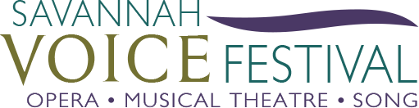
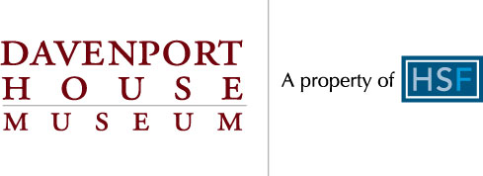
SAVANNAH VOICE FESTIVAL AND DAVENPORT HOUSE MUSEUM PARTNER FOR CONCERT SERIES - ADDITIONAL PERFORMANCE ADDED FOR OCTOBER 15 AT 5PM
SAVANNAH, GA – October 1, 2018 – Due to popular demand, the fall concert of the Davenport House series, “Fall Phantoms and Scary Tunes,” featuring music inspired by Savannah’s haunted past, will now be presented at 5pm on Monday, Oct. 15, 2018 in the Davenport House Museum drawing room. This concert is in addition to the nearly sold out concert which will take place at 7pm and both shows will feature performances by audience favorites from past seasons - Peter Lake, Chad Sonka, Melanie Campbell and Shana Grossman - and introduces new, emerging artists to the Festival, Asmik Arutiuniants and Joanna Pope. Additionally, the American Traditions Vocal Competition Sherrill Milnes American Opera Awardee, Emily Yocum Black, will join the group for this and other October events.

This new collaboration between the Savannah VOICE Festival (SVF) and Davenport House Museum follows a successful partnership with the world premiere of Michael Ching’s opera Anna Hunter, the Spirit of Savannah. In four installments, the Festival Artists will return to Savannah for intimate concerts celebrating the change of seasons in the Davenport House Museum’s drawing room and Kennedy Pharmacy, located at 324 E. State St. on Columbia Square in downtown Savannah.

After the fall concert, this series continues with “Winter Melodies and Crystal Dreams” in a concert of music to set the mood for the holiday season. This varied program of art songs and popular music will be presented at 2 p.m. Sunday, Dec. 2 in the Kennedy Pharmacy, which is located behind the Davenport House at 323 E. Broughton St. The new year brings a new season of “Spring Songs and Blooming Flowers.” With the Davenport House Museum Garden in full bloom, the Festival celebrates with songs inspired by spring. This concert is set for 7 p.m. Monday, March 11 in the drawing room. This series will conclude with a summer concert featuring “Summer Songs of Love” at 7 p.m. Tuesday, June 4 in the drawing room.

“The Davenport House Museum has been such an amazing host and venue for many of our programs and we could not be more thrilled to partner with them again,” said SVF Executive Director Maria Zouves. “Intimate concerts and gatherings are part of our brand at the Savannah VOICE Festival, so adding this series to our profile is a very exciting opportunity to collaborate with our friends at the Davenport!”

Tickets for each concert in this series cost $35 and go on sale Friday, Sept. 21. Tickets will be available for purchase in the Davenport House Museum Gift Shop and on the Davenport House Museum and SVF websites.

This series is a collaborative co-production with proceeds benefiting both SVF and the Davenport House Museum. Learn more about this concert series or purchase tickets by visiting www.savannahvoicefestival.org or www.davenporthousemuseum.org.

– ENDS –
Savannah VOICE Festival is a 501(c) 3 tax exempt nonprofit arts organization in the state of Georgia. The Festival brings classical vocal excellence to the Savannah area through a two-week celebration of concerts, events and educational presentations during the month of August and throughout the year. Focusing on arts awareness and audience development in the performing arts, it offers music from opera, musical theatre and popular song. Donations are tax-deductible.

VOICExperience Foundation is a 501(c)(3) non-profit organization whose mission is to pass on the traditions of great singing and develop new audiences for opera. Under the umbrella of The Sherrill Milnes VOICE Programs, VOICExperience continues its dedication to the quality, integrity and perpetuation of the vocal arts through life-changing intensives, performances, and community-enriching outreach events in New York, Georgia (with its sister organization, the Savannah VOICE Festival), Florida and Illinois. For more information, please visit www.VOICExperienceFoundation.org.

The Savannah VOICE Festival is supported in part by the Georgia Council for the Arts through the appropriations from the Georgia General Assembly. GCA is a Partner Agency of the National Endowment for the Arts.

For media inquiries, please call Hollie Barnidge at 912-272-8651 or email hollie@lesleyfrancispr.com, Lesley Francis at 912-429-3950 or email lesley@francis.com, or the team at 912-417-LFPR (5377).

